Mobile Network

📶 What Are Mobile Networks?
# Source: AI Source: Provided by: [Data Path: Persons Table -> ID Column: 1, Name_En Column: Motasem Essam] -> From: [ChatGPT] on [1/23/2026]
A Mobile Network is a wireless communication system that enables mobile devices—like phones, tablets, and IoT devices—to connect and communicate using radio waves, rather than fixed cables.

🔍 Simple Definition
# Source: AI Source: Provided by: [Data Path: Persons Table -> ID Column: 1, Name_En Column: Motasem Essam] -> From: [ChatGPT] on [1/23/2026]
A mobile network lets you make calls, send texts, and access the internet without needing Wi-Fi or wired connections—anywhere your carrier has coverage.

🧱 Main Components of a Mobile Network
# Source: AI Source: Provided by: [Data Path: Persons Table -> ID Column: 1, Name_En Column: Motasem Essam] -> From: [ChatGPT] on [1/23/2026]
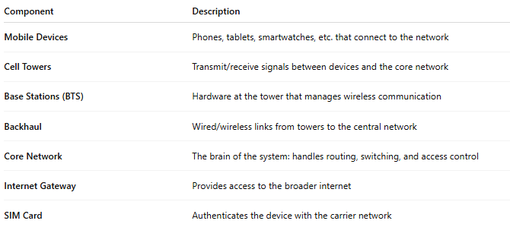
Component | Description
Mobile Devices | Phones, tablets, smartwatches, etc. that connect to the network
Cell Towers | Transmit/receive signals between devices and the core network
Base Stations (BTS) | Hardware at the tower that manages wireless communication
Backhaul | Wired/wireless links from towers to the central network
Core Network | The brain of the system: handles routing, switching, and access control
Internet Gateway | Provides access to the broader internet
SIM Card | Authenticates the device with the carrier network

🧠 Technologies Used in Mobile Networks
# Source: AI Source: Provided by: [Data Path: Persons Table -> ID Column: 1, Name_En Column: Motasem Essam] -> From: [ChatGPT] on [1/23/2026]
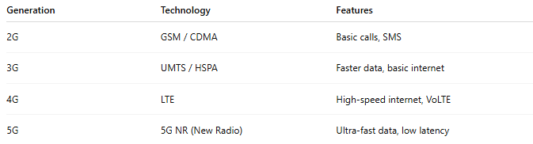
Generation | Technology | Features
2G | GSM / CDMA | Basic calls, SMS
3G | UMTS / HSPA | Faster data, basic internet
4G | LTE | High-speed internet, VoLTE
5G | 5G NR (New Radio) | Ultra-fast data, low latency

📡 Types of Mobile Networks
# Source: AI Source: Provided by: [Data Path: Persons Table -> ID Column: 1, Name_En Column: Motasem Essam] -> From: [ChatGPT] on [1/23/2026]
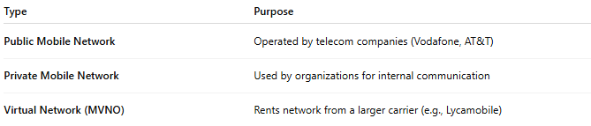
Type | Purpose
Public Mobile Network | Operated by telecom companies (Vodafone, AT&T)
Private Mobile Network | Used by organizations for internal communication
Virtual Network (MVNO) | Rents network from a larger carrier (e.g., Lycamobile)

📱 Mobile Network Use Cases
# Source: AI Source: Provided by: [Data Path: Persons Table -> ID Column: 1, Name_En Column: Motasem Essam] -> From: [ChatGPT] on [1/23/2026]
- Making calls and sending SMS 📞💬
- Browsing the web via 3G, 4G, 5G 🌐
- Location-based services (GPS) 📍
- Streaming video and audio 🎬🎧
- IoT connectivity for smart devices 🔌📡

